**Instructions**

In this activity, you will be sampling beer and learning a bit about beer criticism. In order to do this, you will need the following:

* pint glass (can be found in many stores, try to look for an imperial pint glass, which is 20 oz. If you don’t have that, just make sure you use a clear and clean glass)
* 3 beers of your choice

Many places that sell beer have a “mix and match” section where you can pick out bottles to fill a 6 pack. Also, there are some places around Columbus and in other areas that sell single bottles. Additionally, it is permissible to order a flight of beers at a local pub (if they offer flights). Be sure to ask your instructor if you need suggestions.

If you have them, the following glasses are good additions to your collection:

* pilsner or weisen glass (best for wheat beers and lagers)
* tulip glass or snifter (high alcohol beers (around 11-12% ABV) and most Belgian beers are best served in these)

Follow the directions below to fill out your tables.

1. Record the brand name, specific style (i.e. not just “ale” or “lager”) and ABV of the beer in the appropriate spaces.
2. Pour the beer into the glass using a standard pour. For information on how to do this, refer to <https://www.youtube.com/watch?v=xdgd2m4hAxc>. Take a picture of the beer in the glass (along with your name on a sheet of paper) and paste the photo at the bottom of the form for verification/validation. **NOTE: THIS IS VERIFICATION/VALIDATION IS VERY IMPORTANT. DO NOT LEAVE THIS OUT!!!**
3. Circle or somehow indicate on the color range the color that is applicable for your beer.
4. Highlight the length of time it takes for the head to dissipate. If your pour was not good, this will be difficult to properly gauge. Just take your best guess.
5. Does the head leave lacing (foam stuck on the glass) when it dissipates? Mark yes or no. If you are unsure what lacing is supposed to look like, check out this video: <https://www.youtube.com/watch?v=oGYiNM7HJU8>
6. Take a sip of beer and hold the liquid in your mouth for a while. Work the beer into your tongue and taste buds by rubbing your tongue against your hard palate. Swallow, then breathe in through your mouth and out through your nose. Highlight ALL the flavors that you can detect. Please note that it is very rare for a beer to have malt, hops, and yeast flavors all at once. Also, be honest. Use your senses as your guide. There’s really no “right” answer.

**HINT: Taste the beer 3 times. On the first sampling, try to pick up on any hops tastes. On the second sampling, try to pick up on any malt tastes. On the third sampling, try to pick up on any malt tastes.**

1. Pick the most intense flavor in 6). Type/write in the taste and note the level of intensity on a scale from 1 -5 in the next cell over. The intensity is really subjective, and it should be based on your past experiences. You can use any food or beverage as a reference for this, not just beer.
2. Take another sip of beer. Mark all the mouthfeel descriptors that apply under “Carbonation”, “Body”, and “Astringency”.
3. Swallow the beer. Highlight the words that best describe the aftertaste.
4. On the bottom cell, write your personal impressions. You should answer the following:
   1. Did you enjoy the beer?
   2. What did you like the most about the beer? The least?
   3. Was the beer true to the style? In other words, if the beer was an IPA, did it taste like an IPA “should”?
5. Repeat all the above directions with your remaining 2 beers. If you plan on sampling multiple beers in one sitting, it is best to eat or drink a palate cleanser (bread/crackers and water work well) between beers. Remember that you do not have to drink all of the beer, and it is not advisable to complete this activity in one sitting if you plan to!

**When you are done, save your document and submit it via Carmen. Make sure that you upload this activity to the “Unit 2 Activity” folder. If you do this work with your friend, do not pool/share your answers. I want to know about your own experiences, not yours and your friend’s!**

|  |  |  |  |  |
| --- | --- | --- | --- | --- |
| Student Name Shahil Merchant Date: 3/4/2025 | | | | |
| Name (brand) | Urban Artifact - Chime | | | |
| Style (specific) | American fruit Tart | | | |
| ABV | 6.7% | | | |
| Color (check one) |  | | | |
| Head retention | **< 30 sec 30-60 sec 60-90 sec > 90 sec** | | | |
| Lacing? | **Yes No** | | | |
| Flavor (circle all that apply) | **Hops: earthy, grassy, floral, perfume, spicy, minty, citrus, grapefruit, piney, none**  **Malt: grainy, cracker, bready, bread crust, toast, roast, coffee, sweet, chocolate, nutty, toffee, caramel, none**  **Yeast: fruity, banana, apricot, cherry, vinous, spicy, pepper, clove, sour, acidic, barnyard, horse blanket, leather, goaty, wet hay, none** | | | |
| Intensity of taste | **Most intense taste: Sour** | | **Level of intensity (relative to past experience):**  **1 2 3 4 5** | |
| Mouthfeel (circle one in each cell) | **Carbonation**  **none light medium heavy** | **Body**  **light medium full** | | **Astringency**  **none mild high** |
| Finish (circle one) | **bitter smooth watery** | | | |
| Personal Impressions | Did you enjoy the beer?  Yes, it was pretty different from anything I’ve had | | | |
| What did you like the most about the beer? The least?  **I really liked how faithful to the name it was. I found it a little too sour for my preference, and the astringency to be quite high** | | | |
| Was the beer true to the style?  Yes | | | |

Paste photo below or on a page after the tables. If you opt to do the latter, make sure I know what beer goes with which table.

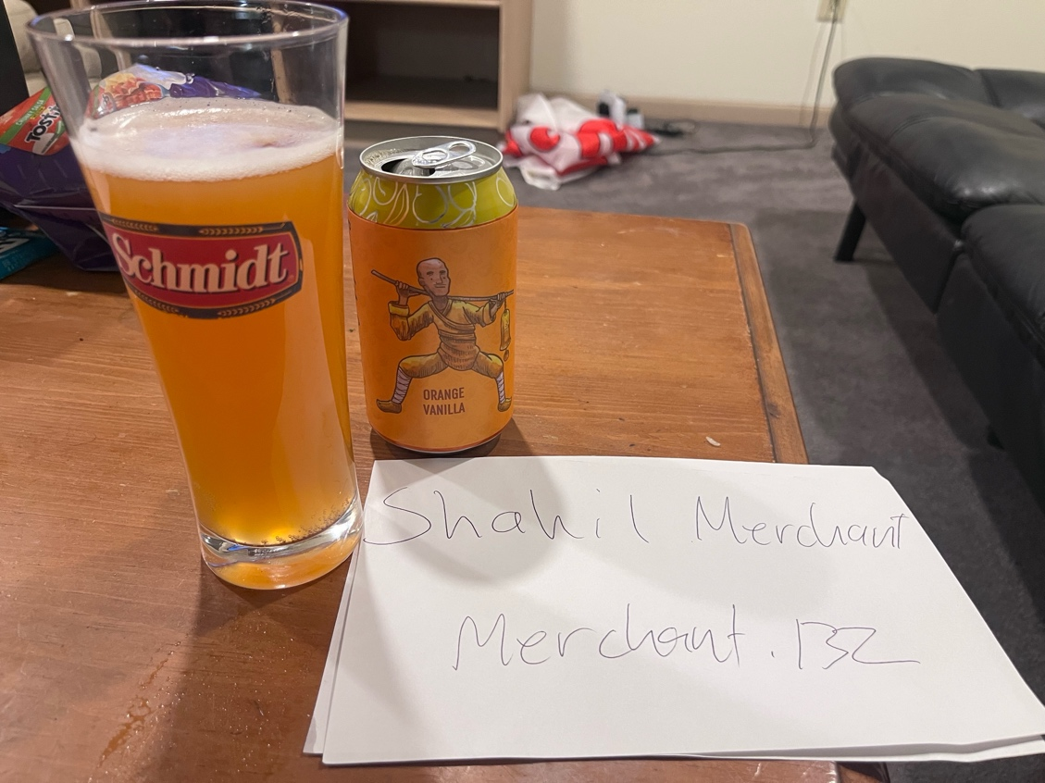

|  |  |  |  |  |
| --- | --- | --- | --- | --- |
| Student Name ____________________ Date: ____________________ | | | | |
| Name (brand) | Parsons No Brewing Co | | | |
| Style (specific) | Mexican Lager | | | |
| ABV | 5.0 | | | |
| Color (check one) |  | | | |
| Head retention | **< 30 sec 30-60 sec 60-90 sec > 90 sec** | | | |
| Lacing? | **Yes No** | | | |
| Flavor (circle all that apply) | **Hops: earthy, grassy, floral, perfume, spicy, minty, citrus, grapefruit, piney, none**  **Malt: grainy, cracker, bready, bread crust, toast, roast, coffee, sweet, chocolate, nutty, toffee, caramel, none**  **Yeast: fruity, banana, apricot, cherry, vinous, spicy, pepper, clove, sour, acidic, barnyard, horse blanket, leather, goaty, wet hay, none** | | | |
| Intensity of taste | **Most intense taste: Grassy** | | **Level of intensity (relative to past experience):**  **1 2 3 4 5** | |
| Mouthfeel (circle one in each cell) | **Carbonation**  **none light medium heavy** | **Body**  **light medium full** | | **Astringency**  **none mild high** |
| Finish (circle one) | **bitter smooth watery** | | | |
| Personal Impressions | Did you enjoy the beer?  Yes. This is the kind of beer I would drink a few of in a night. | | | |
| What did you like the most about the beer? The least?  It is a nice fresh light beer overall. I didn’t like the level of carbonation, but due to my own personal preference | | | |
| Was the beer true to the style?  Yes | | | |

Paste photo below or on a page after the tables. If you opt to do the latter, make sure I know what beer goes with which table.

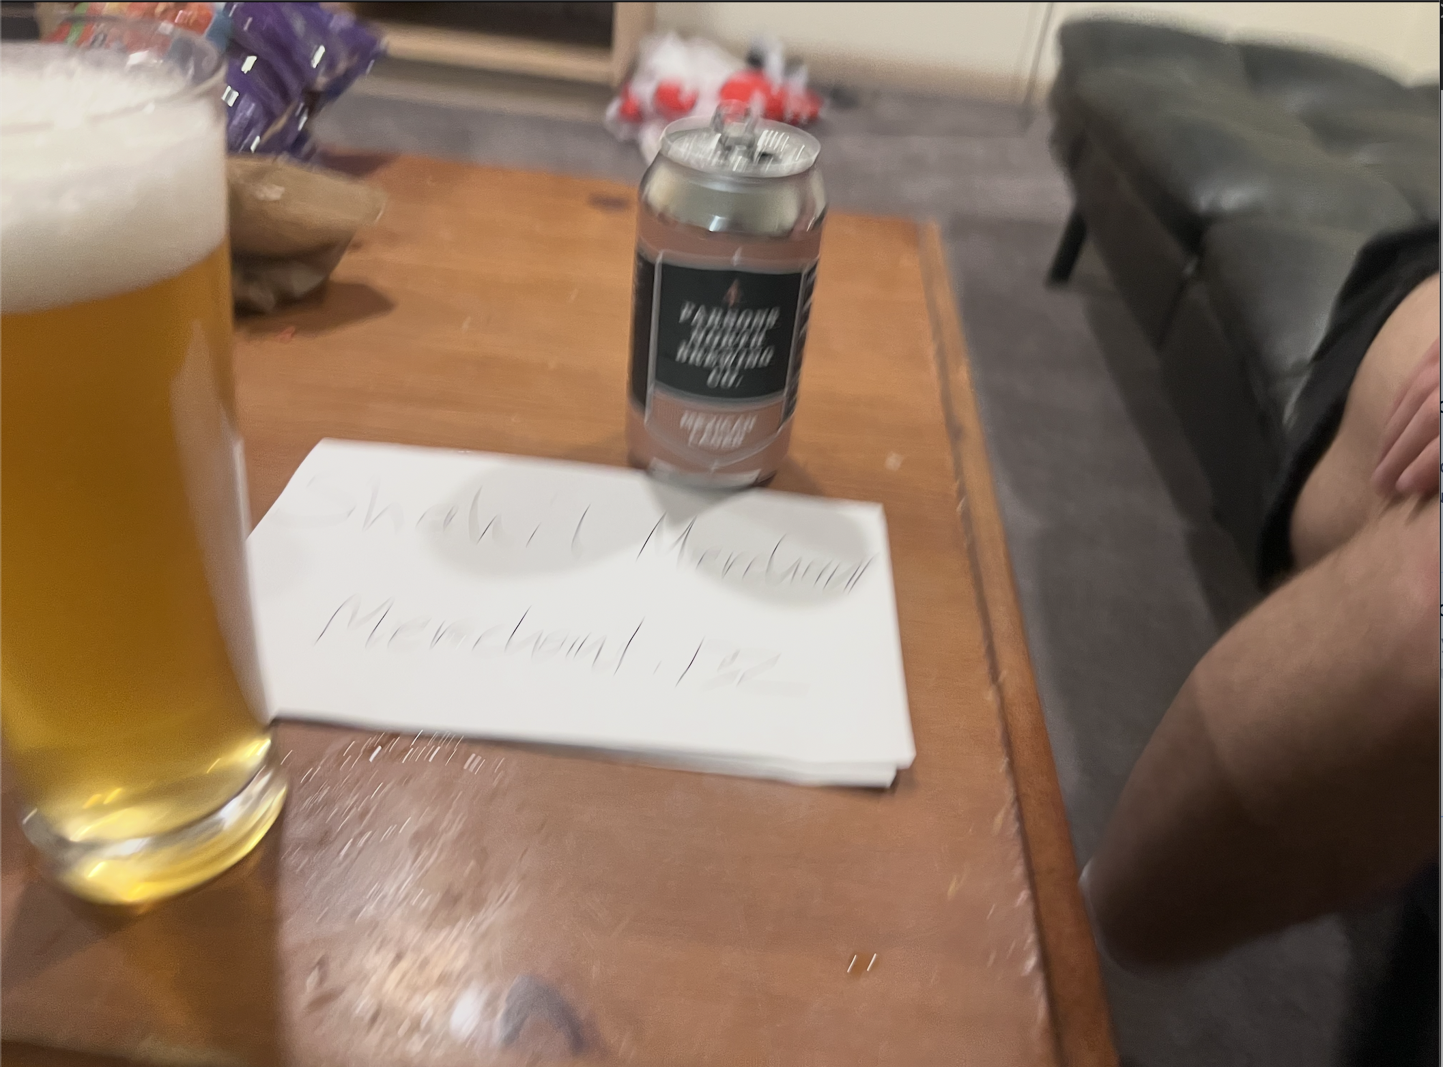

|  |  |  |  |  |
| --- | --- | --- | --- | --- |
| Student Name ____________________ Date: ____________________ | | | | |
| Name (brand) | North High – Filthy McNasty | | | |
| Style (specific) | Imperial Stout | | | |
| ABV | 8.0% | | | |
| Color (check one) |  | | | |
| Head retention | **< 30 sec 30-60 sec 60-90 sec > 90 sec** | | | |
| Lacing? | **Yes No** | | | |
| Flavor (circle all that apply) | **Hops: earthy, grassy, floral, perfume, spicy, minty, citrus, grapefruit, piney, none**  **Malt: grainy, cracker, bready, bread crust, toast, roast, coffee, sweet, chocolate, nutty, toffee, caramel, none**  **Yeast: fruity, banana, apricot, cherry, vinous, spicy, pepper, clove, sour, acidic, barnyard, horse blanket, leather, goaty, wet hay, none** | | | |
| Intensity of taste | **Most intense taste: Earthy** | | **Level of intensity (relative to past experience):**  **1 2 3 4 5** | |
| Mouthfeel (circle one in each cell) | **Carbonation**  **none light medium heavy** | **Body**  **light medium full** | | **Astringency**  **none mild high** |
| Finish (circle one) | **bitter smooth watery** | | | |
| Personal Impressions | Did you enjoy the beer?  Nope | | | |
| What did you like the most about the beer? The least?  **It was a strong and unique flavor and I can appreciate that. The earthiness was a litte too much for my palette.** | | | |
| Was the beer true to the style?  Yes | | | |

Paste photo below or on a page after the tables. If you opt to do the latter, make sure I know what beer goes with which table.

